Jenkins of type deployment

apiVersion: extensions/v1beta1

kind: Deployment

metadata:

name: jenkins

labels:

app: jenkins

spec:

selector:

matchLabels:

app: jenkins

replicas: 1

template:

metadata:

labels:

app: jenkins

spec:

containers:

- name: jenkins

image: jenkins

ports:

- containerPort: 80

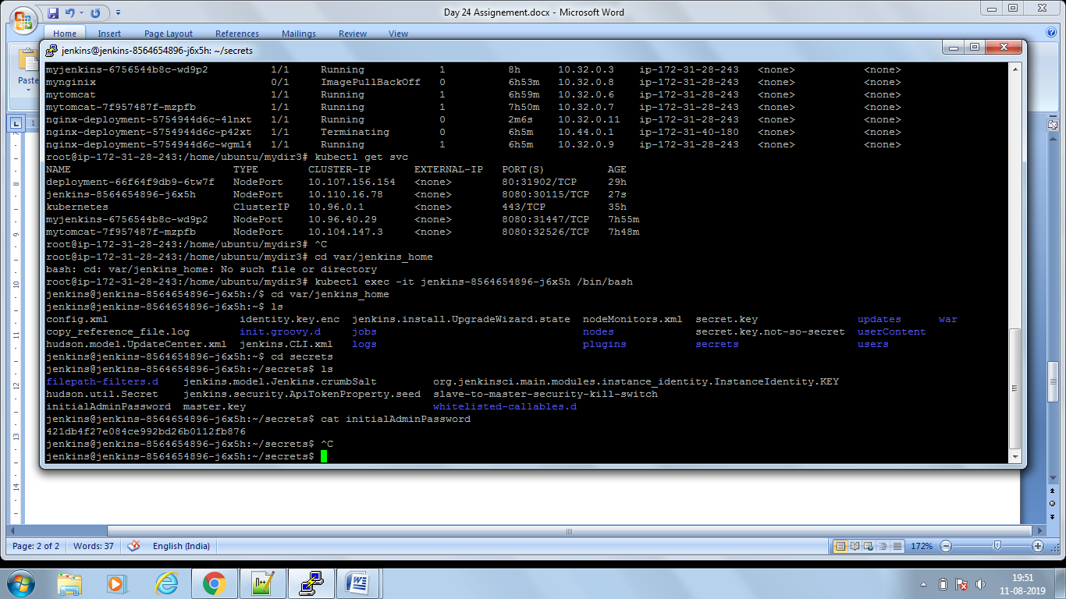

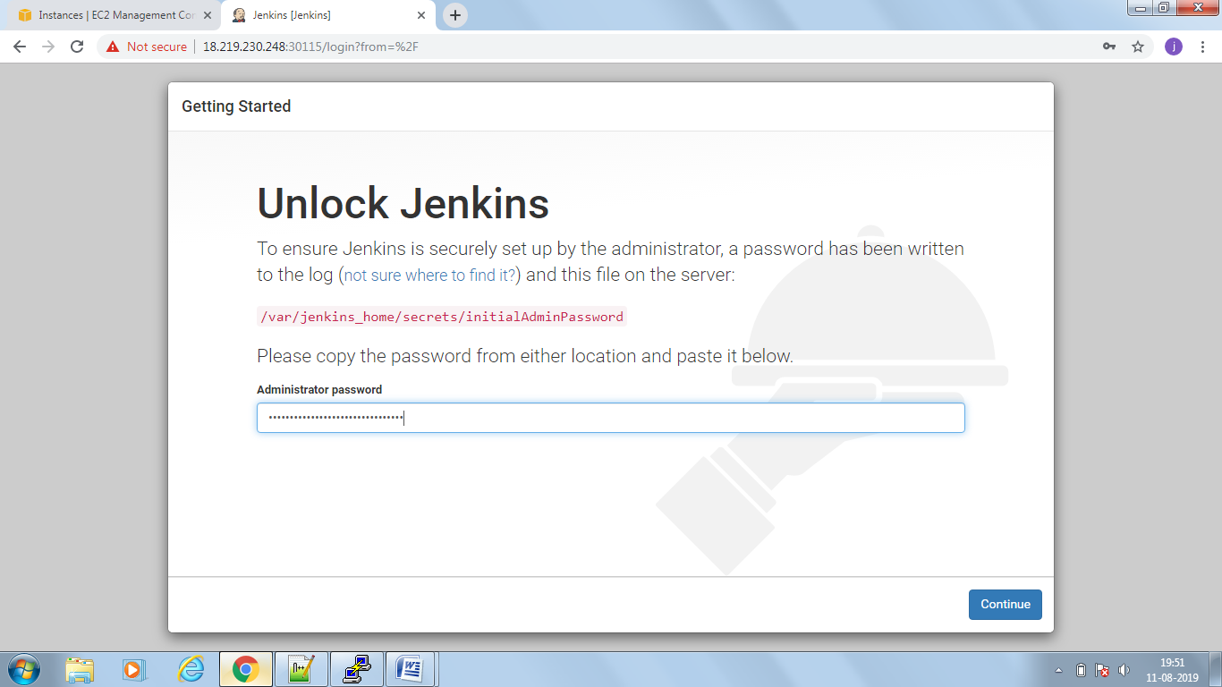

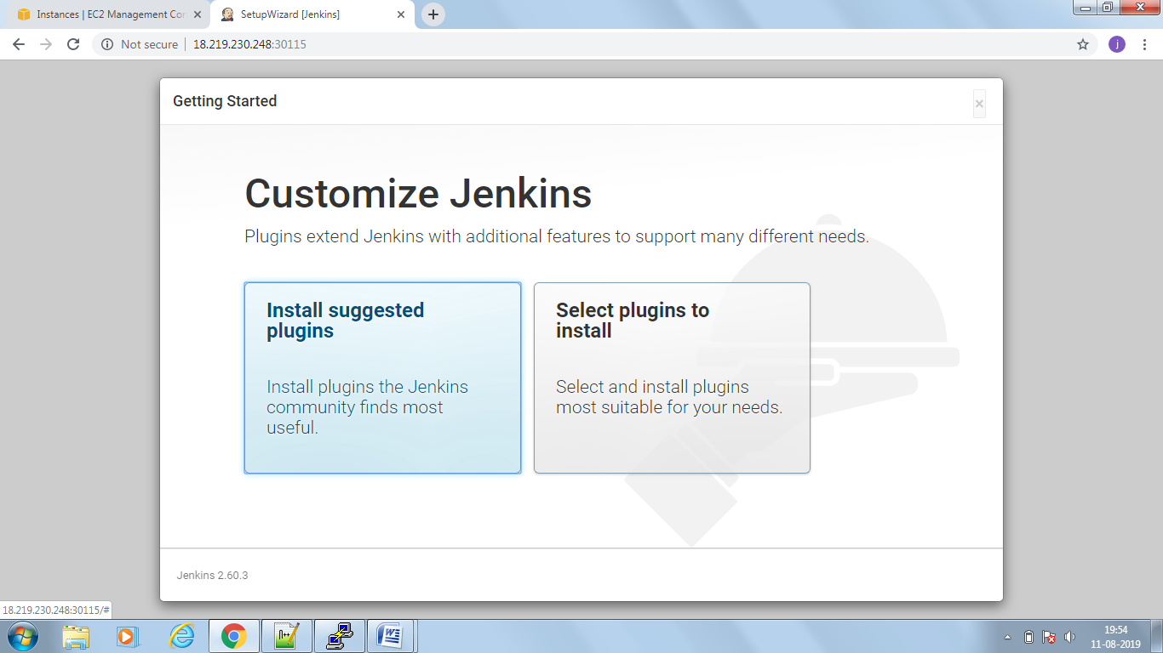

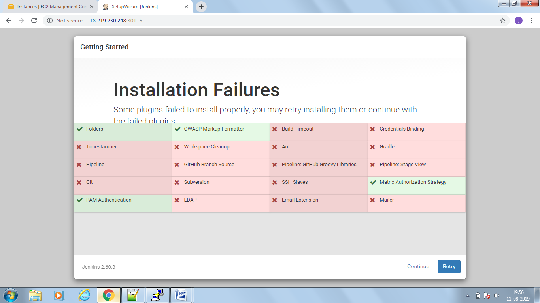

===========deployment kind of Apache

apiVersion: apps/v1

kind: Deployment

metadata:

name: webserver

labels:

app: apache

spec:

replicas: 1

selector:

matchLabels:

app: apache

template:

metadata:

labels:

app: apache

spec:

containers:

- name: php-apache

image: httpd

ports:

- containerPort: 80

